Yield Canned Report
Initial Data Analysis
Progress Report: 10/30/17

1 Goal
The goal of this canned report was to provide up-to-date analysis on COB inventory and product yields. It ideally should be able to assess the value of COB units in inventory, weighted against the orders for each end product, and the test results of each COB unit.
Overall Report Calculation:
- Assign Value to each COB unit (≥ 1 predictive metric)
- Assign Weight to Inventory Channel (≥1 historical metric / predictive metric)
- Calculate Value of Each Inventory (sum of predictive scores * weight)

2 Parameters
Here are listed some of the potentially useful parameters to be used in calculating the value of COB units in inventory
- Order history of end products
  - Used to calculate the likelihood of a COB unit being used to fulfil an end product
- COB test data
  - Used as a predictive scoring metric for the COB unit
  - Requires a strongly correlated actual scoring metric to be predictive
- Time spent in inventory
  - Used as an actual scoring metric for the COB unit
  - Only useful if higher quality COB units are used sooner than poorer quality COB units (as opposed to units being selected at random, for example)
- LM test data
  - Also used as an actual scoring metric for the COB unit
  - Depends on proper correlations between COB test data and LM test data

3 Pseudo-Calculations
Here are some of the potential calculations that can be made with the parameters. Our goal is to have at least 1 predictive metric (3.1, 3.2, 3.3), and the weights of each channel (3.4)

3.1 LM Scoring Prediction
This calculation depends on COB test data having correlations with LM test data.
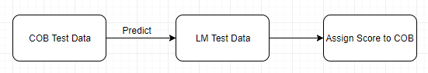
Usefulness:
- If we can predict LM test data by looking at COB test data, we can give COB units in inventory a predicted score while in inventories

3.2 Predicting Time Spent in Inventory By COB Test Data
This calculation depends on COB test data having correlations with the time the COB unit spends in inventory. In other words, it requires that COB units with certain qualities (as shown in their test data) are picked more often/sooner than other units, and that the selection process is not random
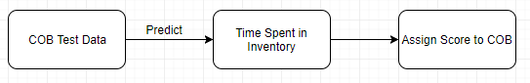
Usefulness:
- Similar to the previous calculation, this would also give us a way to quantitatively score COB units in inventory based on their test data, and predict how likely each unit is to be used

3.3 Distribution of Time Spent in Inventory
This calculation looks for a distribution of time spent in inventory. In other words, it attempts to use how long a unit has spent in inventory as a predictive measure of how much longer it will stay there, or if it will be used at all.
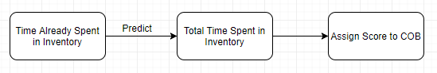
Usefulness:
- Similar to the previous two calculations, this also provides a predictive score

3.4 Historical Order Frequency
This calculation simply looks at historical order rate of certain products.
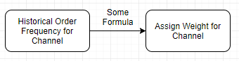
May further look at if there are trends across certain months, etc.
Usefulness:
- Provide weights to each COB inventory

3.5 Final Calculation: Predict Value of COB Unit in Inventory
This calculation requires at least one predictive quality of COB units (3.1, 3.2, 3.3), and the weight of the channel it belongs to (3.4), to assign a value to the unit.
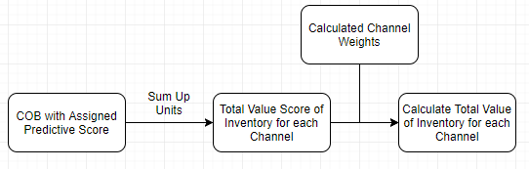
Usefulness:
- This is the goal canned report to be made, which represents the value of each inventory

4 Data
This section outlines where we will retrieve data from.

4.1 COB Test Data
SQL Table: OrtelTE.dbo.ChirpSpecTrumData
Example Query: SELECT TOP 10 * FROM OrtelTE.dbo.ChirpSpecTrumData WHERE Batch='5836220' AND CHIP='CO122'
TestTemp, PredictChannel, SMSR, Chirp

SQL Table: OrtelTE.dbo.LIDataBase
Example Query: SELECT TOP 10 * FROM OrtelTE.dbo.LIDataBase WHERE Batch='5836220'
Ith, Power, Efficiency, WL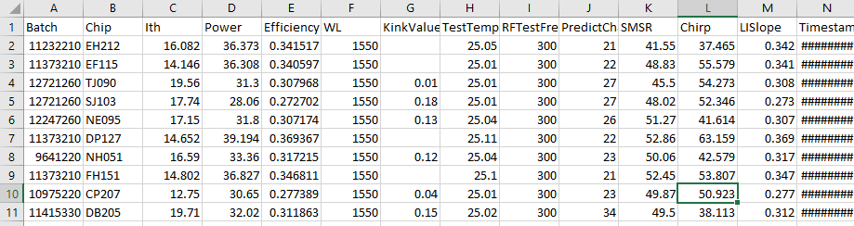

4.2 LM Test Data
SQL Table: OrtelTE.dbo.ModuleFailSMSR
Example Query: SELECT TOP 10 * FROM OrtelTE.dbo.ModuleFailSMSR WHERE Device_SN = 'BFC5265'
WaveLen, SMSR, Ith, Slopeff, Temperature

SQL Table: OrtelTE.dbo.LaserModuleShippingData
Example Query: SELECT TOP 10 * FROM OrtelTE.dbo.LaserModuleShippingData WHERE Device_SN = 'BFC5265'
Chirp
Morteza’s Data
Data from Morteza on LM units was identical to the data in these tables, so we used those
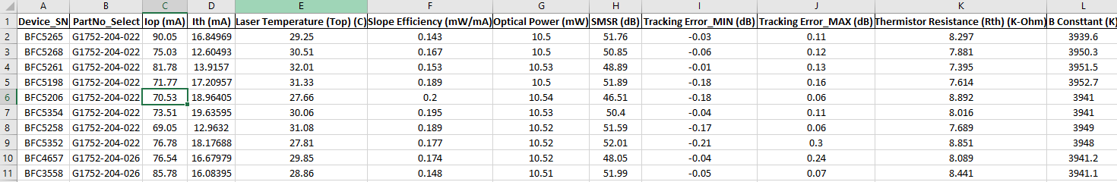

4.3 LM-COB Linking
SQL Table: OrtelTE.dbo.ModuleDistortion
Example Query: SELECT TOP 10 * FROM OrtelTE.dbo.ModuleDistortion WHERE Device_SN = 'BFC5265'
Links LMs with their corresponding COB chip, so we can find the COB test data related to it
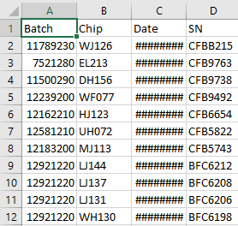

4.4 Historical Order Data
LM Consumption Data:
Data provided by Marc Cavagnolo shows monthly consumption for LMs per channel. This can be considered as a measure of orders for units in each channel
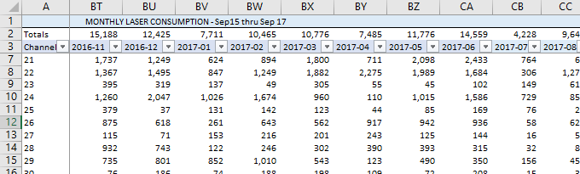

5 Data Collection and Initial Analysis
This section outlines the process of initial data analysis.

5.1 Data Collection Process
- Collect LM serial numbers from Morteza’s data (Section 4.2)
- Collect matching COB batch and chip IDs (Section 4.3)
- Collect COB test data for these units (Section 4.1)
Data for about 10,000 units was collected in this process for analysis

5.2 COB Test Data Initial Check
- Check to see which parameters of COB test data might be useful for analysis
Fig 1. Histogram of All Collected Data Types in COB Data
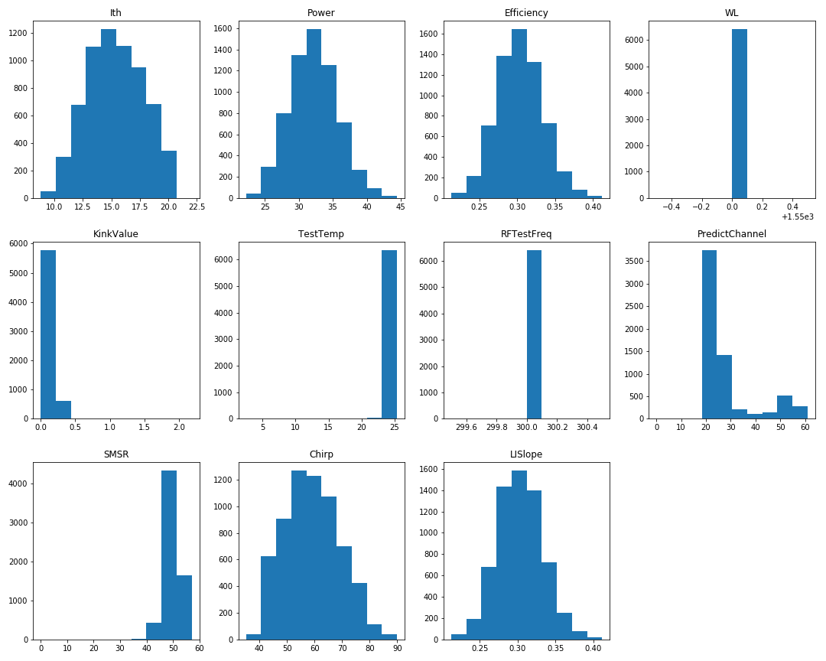
- A few pieces of test data are pretty much always the same value (Wavelength, TestTemp, RFTestFreq)
- PredictChannel is likely based on other values, and is oddly distributed
- Below are the normally distributed pieces of test data, which will be used for analysis
Fig 2. Histogram of Distributed Test Data Types in COB Test Data
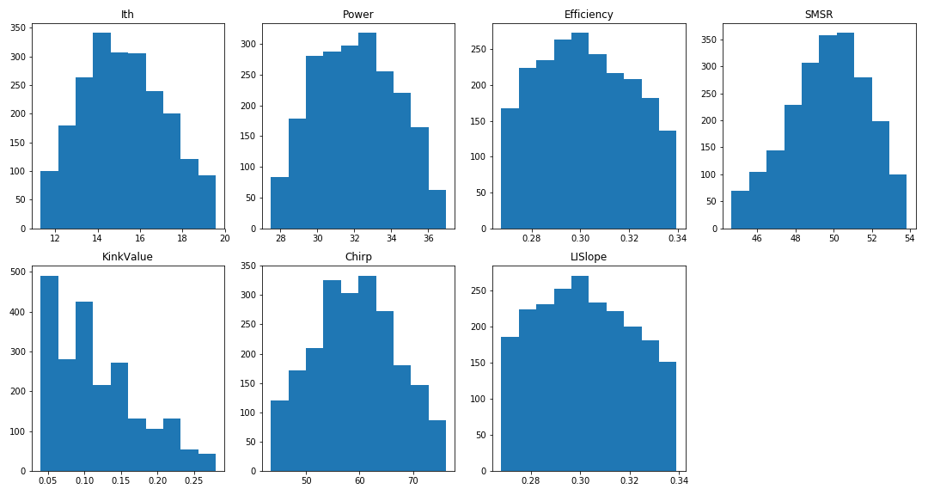

5.3 Data Cleaning
- Remove any rows with missing data in any of the above 7 test data types (Ith, Power, Efficiency, SMSR, Kink, Chirp, LISlope)
- Remove outliers by removing rows where values are outside 1st or 99th percentile (* May revoke this step when running models)

Initial Analysis of Monthly LM Consumption
Corresponds to Section 3.4
- Data collected from Marc Cavagnolo’s LM monthly consumption data
Fig 3. Average Monthly LM Consumption by ITU Channel
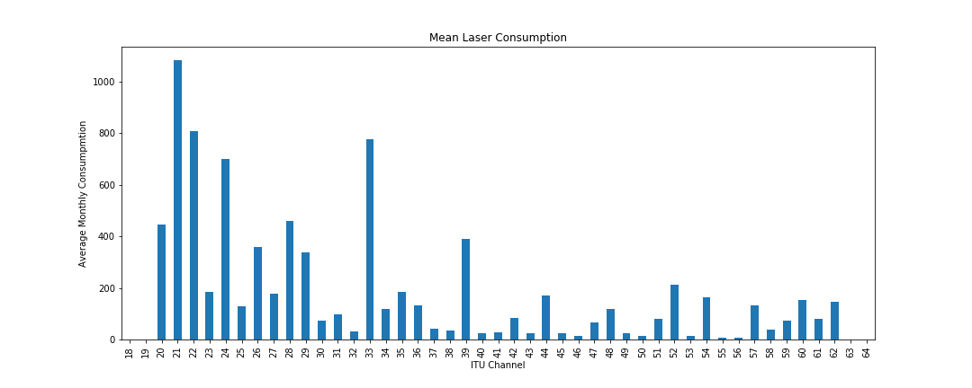
Fig 4. Histograms of Monthly LM Consumption by ITU Channel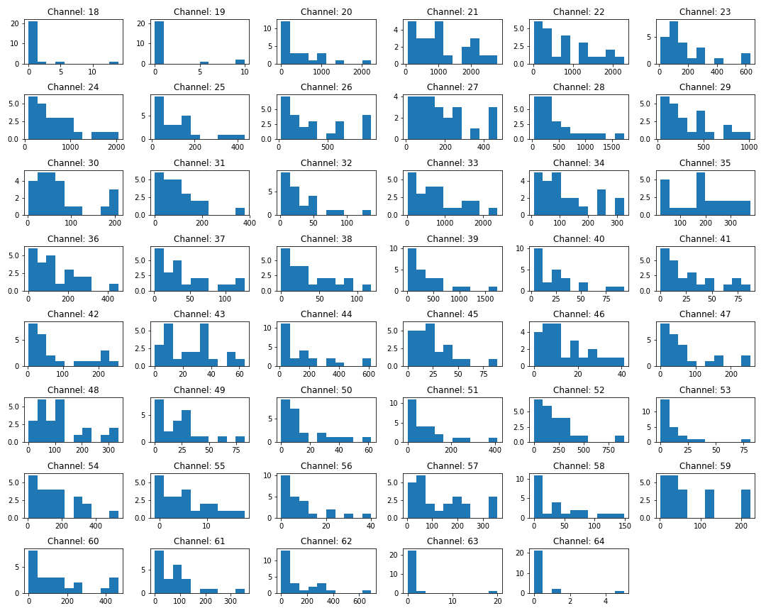

Fig 5. Rolling Average (3 Months) of LM Monthly Consumption By ITU Channel
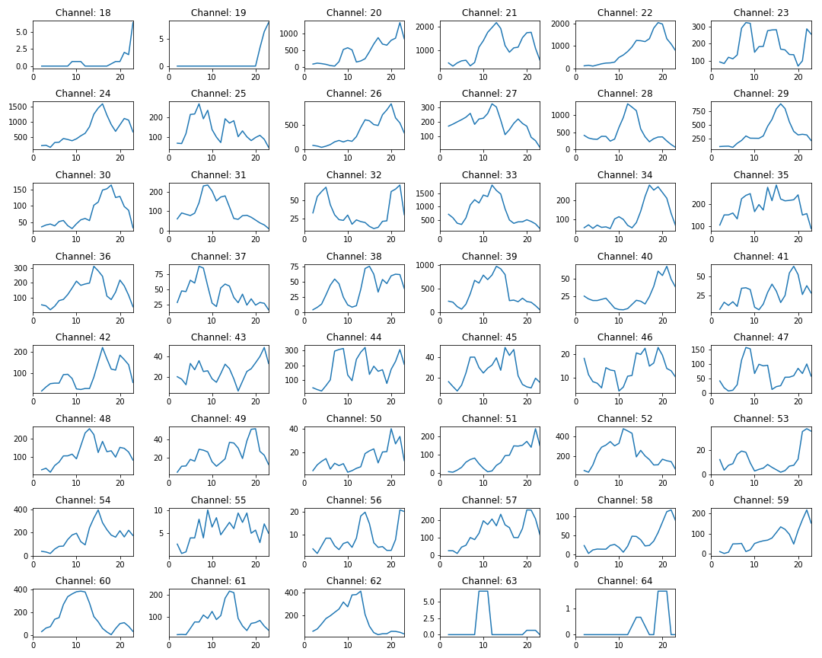
Fig 6. Correlation of Consumption Between One Month and the Next
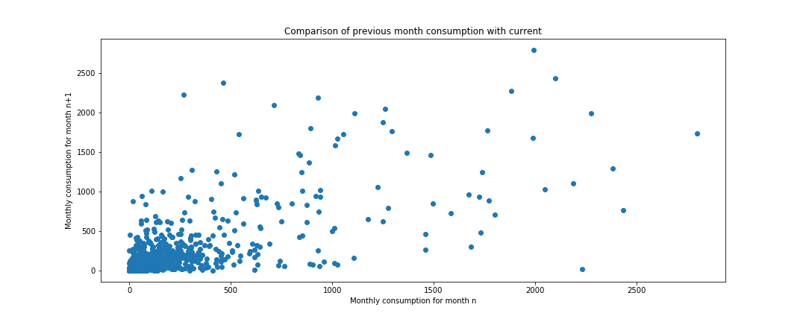

Fig 7. Rolling Average (3 Months) of LM Monthly Consumption By ITU Channel
(Highlighted Mean > 300)
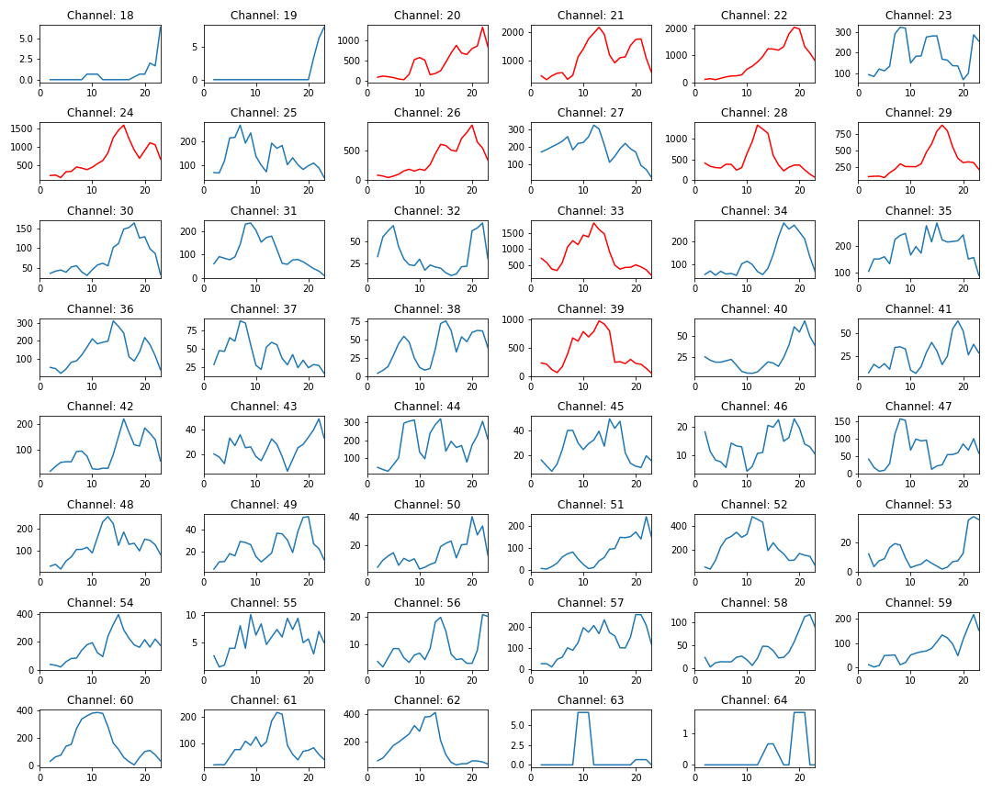

Monthly LM Consumption Conclusions
- It is difficult to predict the next month’s orders based on the previous months (Fig 5, 6)
- Most channels have a positive-skewed normal distribution (Fig 4)
- Historically high order rate is not entirely indicative of future rates (Fig 7, especially channels 28, 29, 33, 39)
- May be helpful for further analysis of channel rolling averages to be normalized against global rolling averages, as it looks like many trends share peaks and troughs
  - Further, looks like some patterns may even be clustered into order patterns (single middle peak, two left/right peaks, generally bumpy), which may indicate different customers

5.5 Initial Analysis of Time Spent in Inventory
Corresponds to Section 3.3
- Calculate time spent in inventory as:
  - (Date of LM test data entry) – (Date of COB test data entry)
  - Test data entry using most recent passed entry
  - May need further refinement of this definition, depending on distribution of analysis

Fig 8. Histogram of COB Time Spent in Inventory
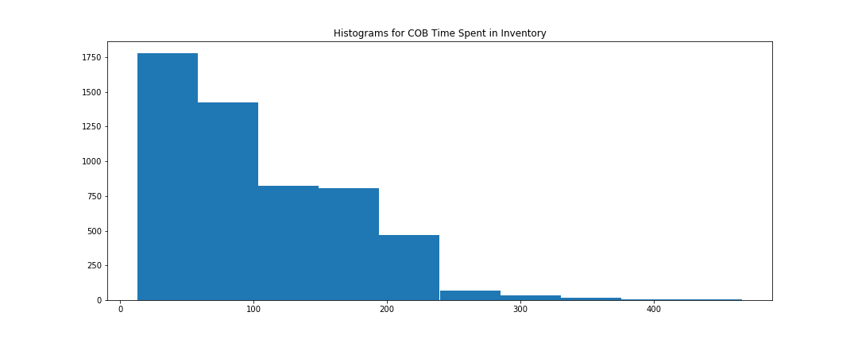
Fig 9. Histogram of COB Time Spent in Inventory (30 Bins)
Higher resolution (smaller group size for histogram bins shows more detail in distribution, but may be more subject to random error) 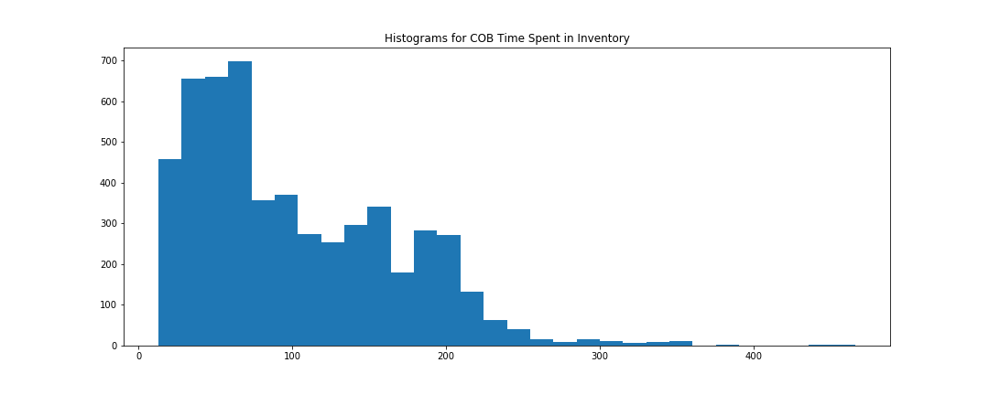

Fig 10. Comparison of COB Test Data Against Time Spent in Inventory
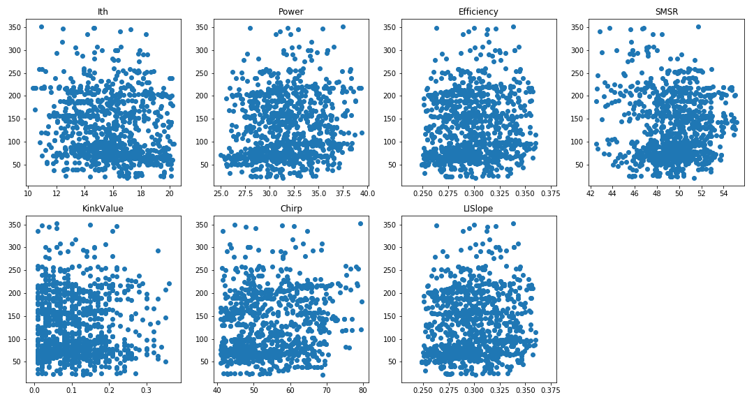

5.5.1 Time Spent in Inventory Conclusions
- Time spent in inventory has a positively-skewed normal distribution, as we might expect (Fig 8, 9)
  - Indicates that most units get chosen early on when put into inventory
  - The longer a unit stays in inventory, the less likely it is to be used
  - Time spent in inventory can be used as a predictive score for likelihood of a unit to be used in the future
- Time spent in inventory does not seem to have correlations with our chosen COB test data
  - These pieces of COB test data cannot be used to predict how long units will stay in inventory for
  - This may also indicate that units are being selected at random with respect to test data?
  - May need to conduct further analysis dividing COB units into groups of their ITU channels (intuitively, we may be choosing COB units with test data appropriate for their ITU channel)

Initial Analysis of COB Test Data Compared Against LM Test Data
Corresponds to Section 3.1
- Goal: Correlate LM Test Data with COB Test Data, to see whether LM Test Data can be predicted
- COB Test Types Used: ['Ith', 'Power', 'Efficiency', 'SMSR', 'KinkValue', 'Chirp', 'LISlope']
- LM Test Types Used (every column from Morteza’s data): ['Iop (mA)', 'Ith (mA)', 'Laser Temperature (Top) (C)', 'Slope Efficiency (mW/mA)', 'Optical Power (mW)', 'SMSR (dB)', 'Tracking Error_MIN (dB)', 'Tracking Error_MAX (dB)', 'Thermistor Resistance (Rth) (K-Ohm)', 'B Consttant (K)', 'CNR @ 61.25 MHz (dB)', 'CNR @ 547.25 MHz (dB)', 'CSO (dB)', 'CTB (dB)', 'Chirp (MHz/mW)', 'Monitor Current (micro-A)', 'Frequency Response (dB)']

- Majority of these LM Test Types had no clear correlation, for example:
Fig 11. COB Test Data vs. LM Frequency Response (dB)
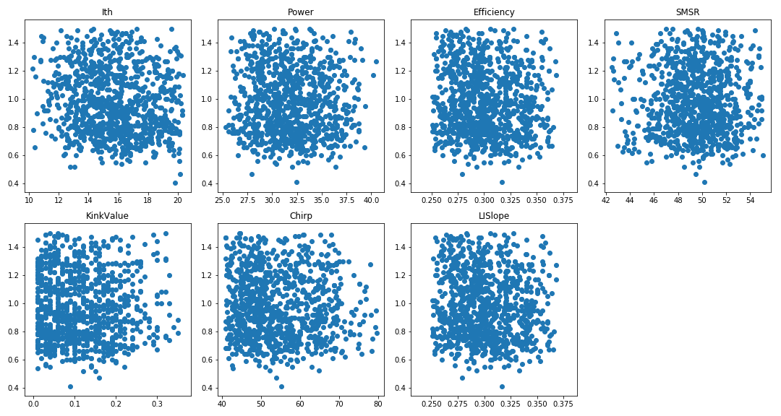
- The only LM Test Types that showed promise were: ['Iop (mA)', 'Ith (mA)', 'Monitor Current (micro-A)', 'Slope Efficiency (mW/mA)', 'SMSR (dB)' ]:

Fig 12. COB Test Data vs. LM Iop (mA)
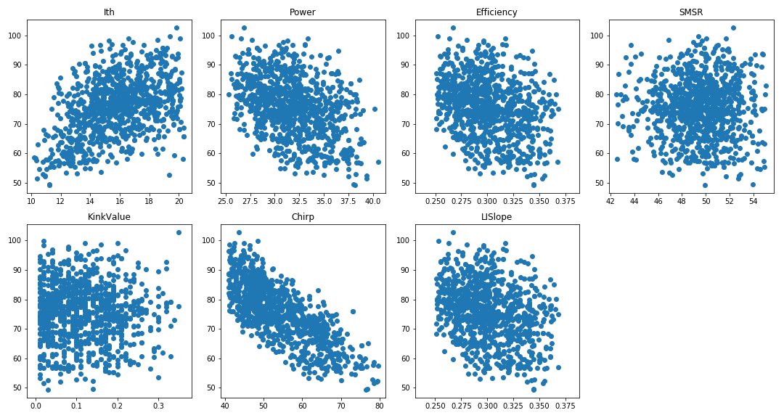

Fig 13. COB Test Data vs. LM Ith (mA)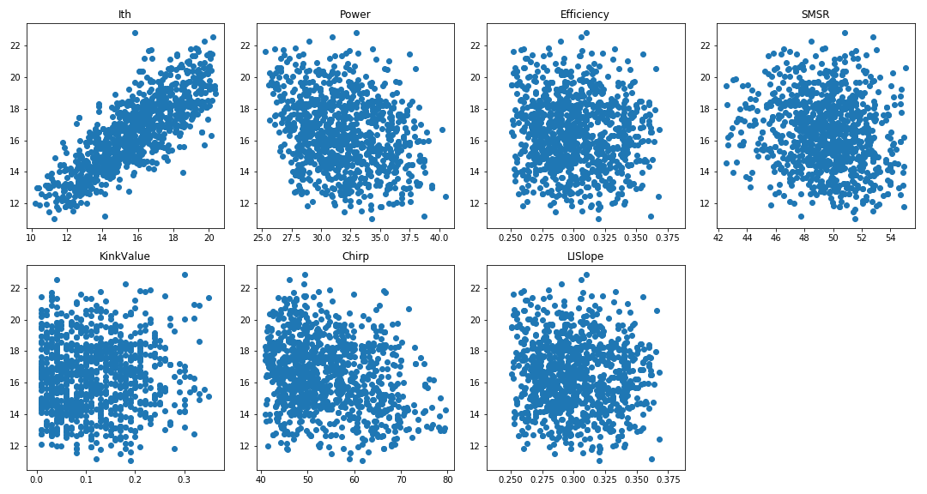

Fig 14. COB Test Data vs. LM Monitor Current (micro-A)
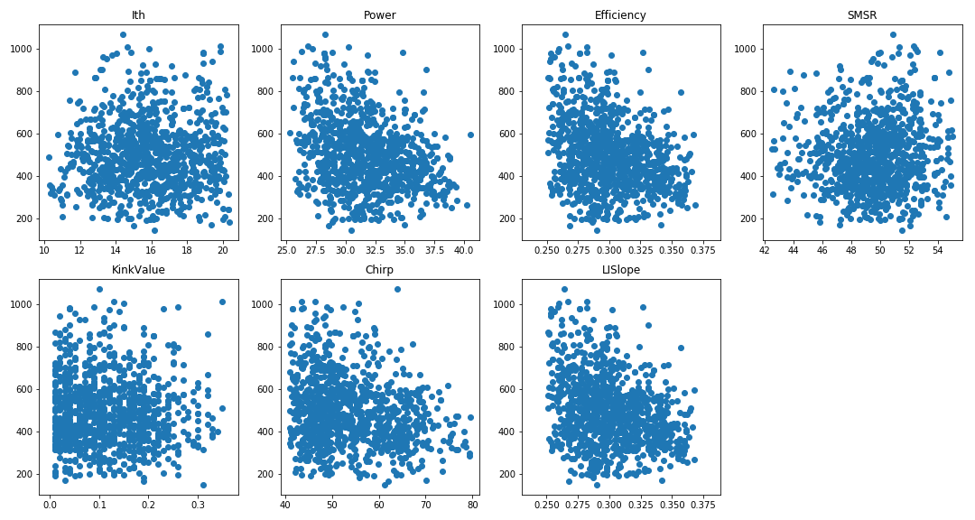

Fig 15. COB Test Data vs. LM Slope Efficiency (mW/mA)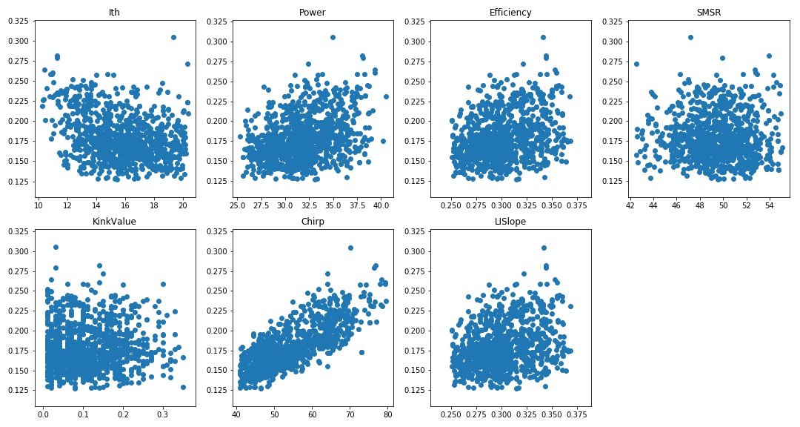

Fig 16. COB Test Data vs. LM SMSR (dB)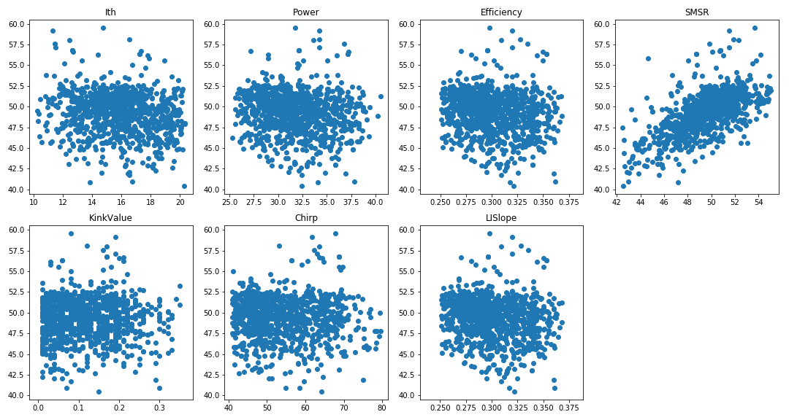

COB-LM Test Data Correlations Conclusions
- SMSR and Ith seem to have correlations between COB and LM stages (Fig 13, 16)
  - Ith also seems to have a small inverse correlation with COB Power and Chirp
- Slope Efficiency, and Iop seem to have other correlations with COB data (Fig 12, 15)
- Monitor Current seems to have general inverse correlations with COB data (Fig 14)
- Unfortunately, some of these correlations look very weak, and are likely to be drowned out by random error if actually attempting to use them for predictions
  - Will have to actually try to model correlations to determine how clear they are

Model Building

6.1

